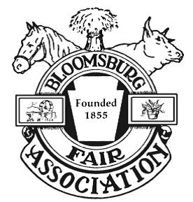
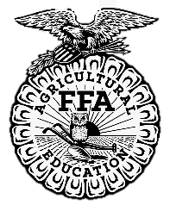
Mary Buczynski
Memorial Livestock Grant

This one time, $300 grant will be available to one youth 4-H and/or FFA member who shows an animal at The Bloomsburg Fair and displays financial need.
Please complete this form and return it to The Bloomsburg Fair Association by Sept. 1, 2021.

Name: __________________________________ Date of Birth: _______________________
Email Address: _____________________________________________________________
Phone Number: ____________________________________________________________

Animal Specie(s) Raised: _______________________________________________________
______________________________________________________________________________

4-H or FFA Clubs you are active in: ______________________________________________
______________________________________________________________________________

Extracurricular Activities and Date involved (Please List):

Include two non-relative references:

Please explain your future plans/goals after high school:
________________________________________________________________________________________________________________________________________________________________________________________________________________________________________________________________________________________________________________________

Please explain and/or give examples on how being a recipient of this grant would benefit your livestock (Use extra space if necessary):
________________________________________________________________________________________________________________________________________________________________________________________________________________________________________________________________________________________________________________________________________________________________________________________________________________________________________________________________________________________________________________________________________________________________________________________________________________________________________________

What is your favorite part and/or memory of raising/showing livestock?
_____________________________________________________________________________________________________________________________________________________________________________________________________________________________________________________________________________________________________________________________________________________________________________________________________

