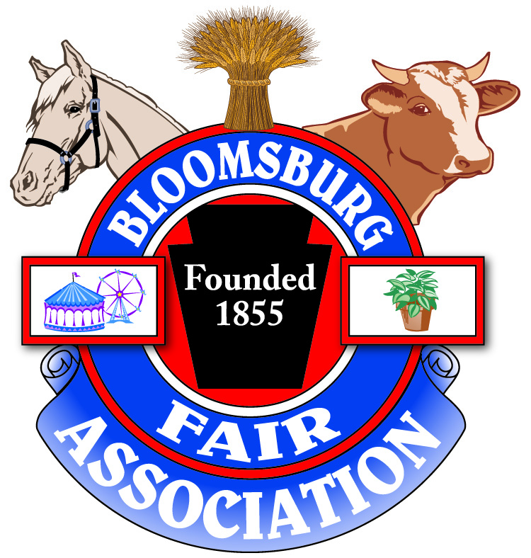
BLOOMSBURG FAIR
VETERAN’S BLOCK ORDER FORM

To order your Bloomsburg Fair Veteran’s Block, please print out and complete this order form and send with your check payable to Bloomsburg Fair to:

BLOOMSBURG FAIR
VETERAN’S BLOCK ORDER
P.O. Box 479
Bloomsburg, PA 17815

PURCHASERS NAME:_____________________________________________

ADDRESS:______________________________________________________

CITY:__________________________ STATE:___________ ZIP:___________

Daytime Phone Number (____)_______________________________
Evening Phone Number (____)_______________________________
TOTAL AMOUNT ENCLOSED $____________________

COMPLETE FORM WHEN ORDERING A 9”x 9” BLOCK.
PRICE PER BLOCK - $100.00
Please allow no more than 14 Characters/Space per line.

Information to be Printed on Block:

Please Indicate Branch of Service (Circle One):

US Army Navy Air Force Marines Coast Guard

Each Dash Represents a Letter/Number/Punctuation or Space
YOU DO NOT NEED TO USE ALL LINES
*PLEASE USE SEPARATE FORM FOR EACH BLOCK ORDERED*

FIRST NAME _ _ _ _ _ _ _ _ _ _ _ _ _ _

LAST NAME _ _ _ _ _ _ _ _ _ _ _ _ _ _

